Title: Family Business

Veland Ramadani (corresponding author)
Faculty of Business and Economics,
South East European University, Tetovo, North Macedonia
Email: v.ramadani@seeu.edu.mk
ORCID ID: 0000-0002-8495-9141 (if available)

Biograhy:
Veland Ramadani is a Professor of Entrepreneurship and Family Business at Faculty of Business and Economics, South-East European University, North Macedonia. His research interests include entrepreneurship, small business management and family businesses. He authored or co-authored more than hundred twenty research articles, eighty book chapters, twelve textbooks and twenty-five edited books. He has published in Journal of Business Research, Technological Forecasting and Social Change, Review of Managerial Science, Technology in Society, International Journal of Entrepreneurial Behavior & Research, among others. He has received the Award for Excellence 2016 - Outstanding Paper by Emerald Group Publishing. In 2017, he was appointed as a member of Supervisory Board of Development Bank of North Macedonia, where for ten months served as an acting Chief Operating Officer (COO) as well. He was ranked, three times in a row, among World's Top 2% of the most influential researchers prepared by Elsevier BV & Stanford University, USA.

Abstract: This paper explores the determining factors that affect family business longevity… (120 words maximum)
Keywords: family business (up to six)

1 Introduction
Studies on the challenges and factors affecting the longevity of family businesses address existing problems related to the ability to pass the business from one generation to future generations (Kraus et al., 2018).

2 Literature review
2.1 Family business concept: Some fundamental insights
The oldest and most prevalent type of economic organization is the family business (Baltazar et al., 2023; Cronqvist & Nilsson, 2003; Rovelli et al., 2022)

Determining factors affecting family business longevity
Among the other factors, the planning and execution of the succession process have a substantial impact on the longevity of family businesses.

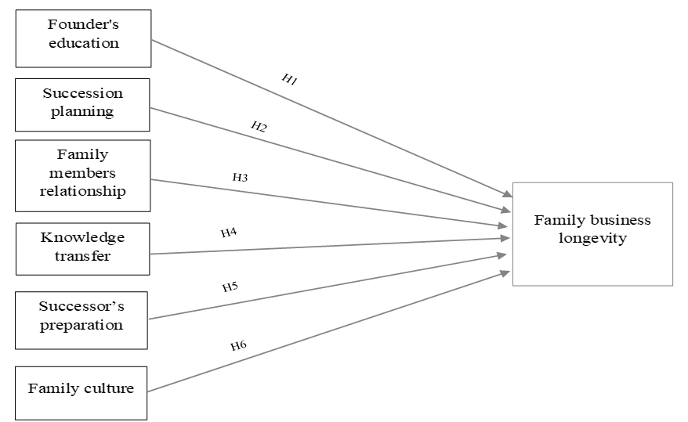

Figure 1. Conceptual framework

In this paper, the focus will be on the impact of the founder's education, succession planning, relationships between family members, knowledge transfer from one to another generation, the successor's preparation for leadership, and family culture on the family business longevity (Fig.1).

2.2.1 Founder’s education
Education is a relevant determining factor of family business longevity.
H1. Founder's education positively affects family business longevity

2.2.2 Succession planning
While succession planning is essential for ensuring the business's longevity, very often questions like: "Who should be chosen as a successor?"; "What do they want?"; "How will the family and the business react?"; "How will they accept the new situation? makes this process very complicated and difficult (Baltazar et al., 2023).
H2. Succession planning positively affects family business longevity

3 Methodology
3.1 Research model and methods
Considering that this study is based on self-reported data, as most other similar studies (Sackett & Larson, 1990), it is a subject to common method variance issues (Podsakoff et al., 2012).

3.2 Research instrument
This study will use a questionnaire since it is the most suitable instrument for this research.

3.3 Sample
Regarding the sample size necessary to perform a study, there are divergent viewpoints.

Descriptive data
The descriptive statistics analysis is presented in this part of the paper.

Table 1. Descriptive data of respondents’ profile (N=356)
Variable | Frequency | %
Gender
Male | 262 | 73.6
Female | 94 | 26.4
Age
20-29 | 45 | 12.6
30-39 | 112 | 31.4
40-49 | 141 | 39.5
50-59 | 56 | 16.0
60+ | 2 | 0.6
Experience
0-5 years | 50 | 14.0
6-10 years | 119 | 33.3
11-20 years | 138 | 38.9
21-30 years | 45 | 12.6
30+ years | 4 | 1.1
Education level
Primary School/ Secondary school | 41 | 11.5
Bachelor's degree | 168 | 47.3
Master's degree | 141 | 39.5
Doctoral degree | 6 | 1.7
Generation
First generation | 211 | 59.1
Second generation | 95 | 26.9
Third generation | 50 | 14.0
Business lifespan
0-5 years | 50 | 14.0
6-10 years | 118 | 33.3
11-20 years | 139 | 38.9
21-30 years | 45 | 12.6
30+ years | 4 | 1.1
Sector
Trade | 104 | 29.1
Services | 125 | 35.3
Production | 60 | 16.8
Agriculture | 23 | 6.4
Real estate | 42 | 11.8
Other | 2 | 0.6
Size
Micro | 91 | 25.5
Small | 178 | 50.1
Medium | 80 | 22.4
Large | 7 | 2.0

4 Findings and discussion

4.1 Reliability analysis
Cronbach's Alpha is advised for testing the reliability of the Likert scale to assess the internal consistency of the variables when the Likert scale is used (Gliem & Gliem, 2003).

4.2. Formula
Therefore, to test the impact of independent variables on family business longevity (dependent variable), a linear regression is performed based on the following model:

Family businesses longevity = β₀ + β₁ (Founder’s education) + β₂ (Succession planning) + β₃ (Family members relationships) + β₄ (Knowledge transfer) + β₅ (Successor’s preparation) + β₆ (Family culture) + ᶓ.

5 Conclusions
The study, which aim was to unveil the determining factors … Kosovo.

5.1 Implications
This study aims to shed light on …

5.2 Limitations and future research directions
Despite the sample size and the number of measures taken to ensure the validity of the study….

Reference

APA style 11pt
Instructions: https://www.mendeley.com/guides/apa-citation-guide/

